AWS ADVANCE BATCH 1 ASSIGNMENT DAY 7 AND 8 LU
PROJECT 1:
VPC PEERING:
Ss1: VPCs list:
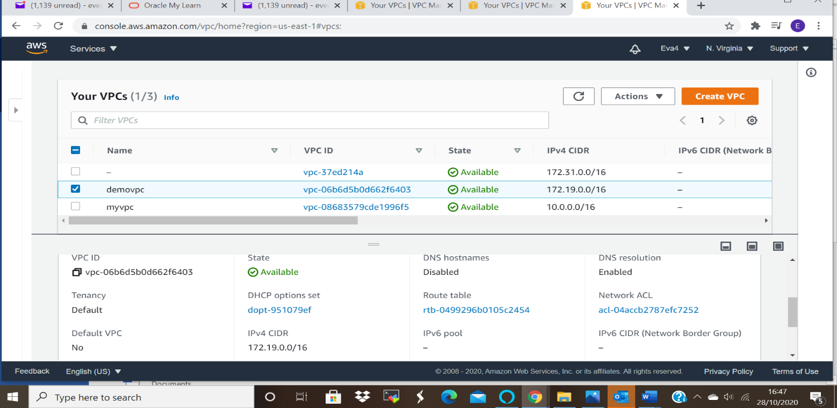
Ss For the second vpc:

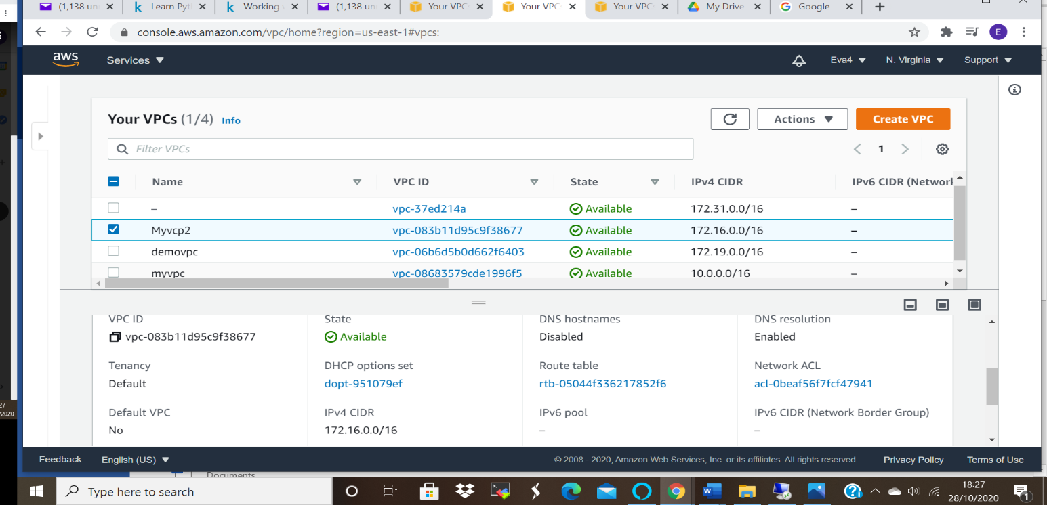

Ss2: IGW list
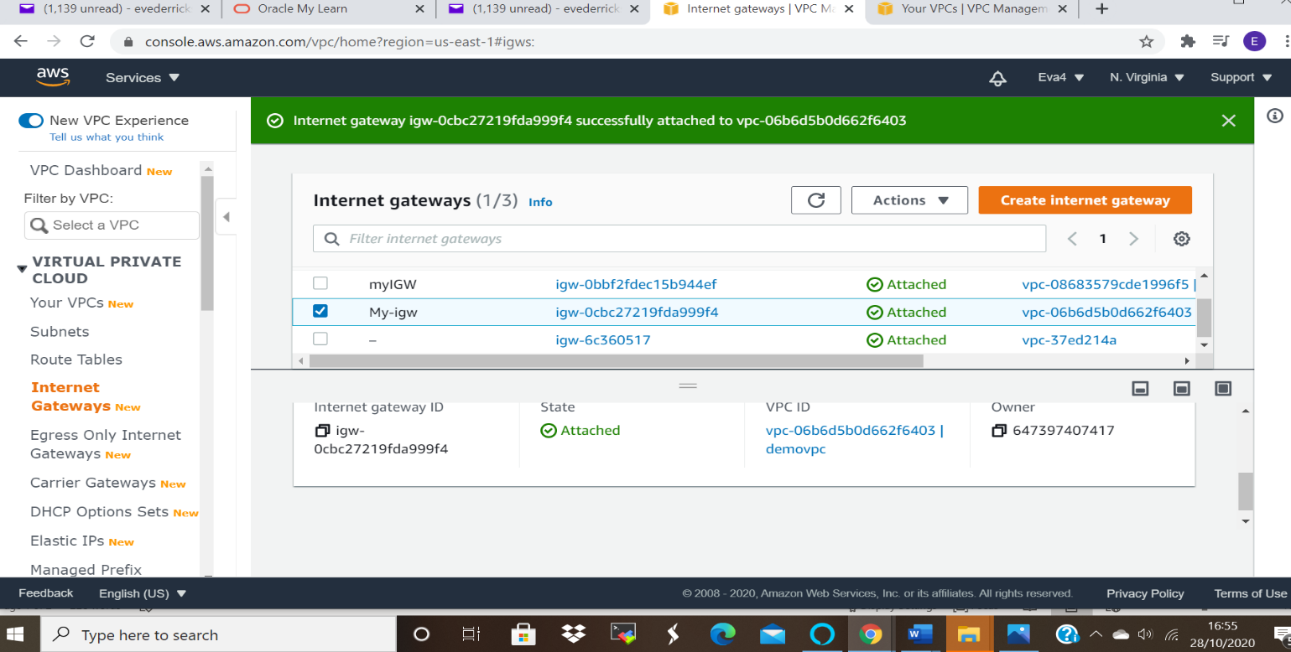
Ss for Second Internet Gateway:
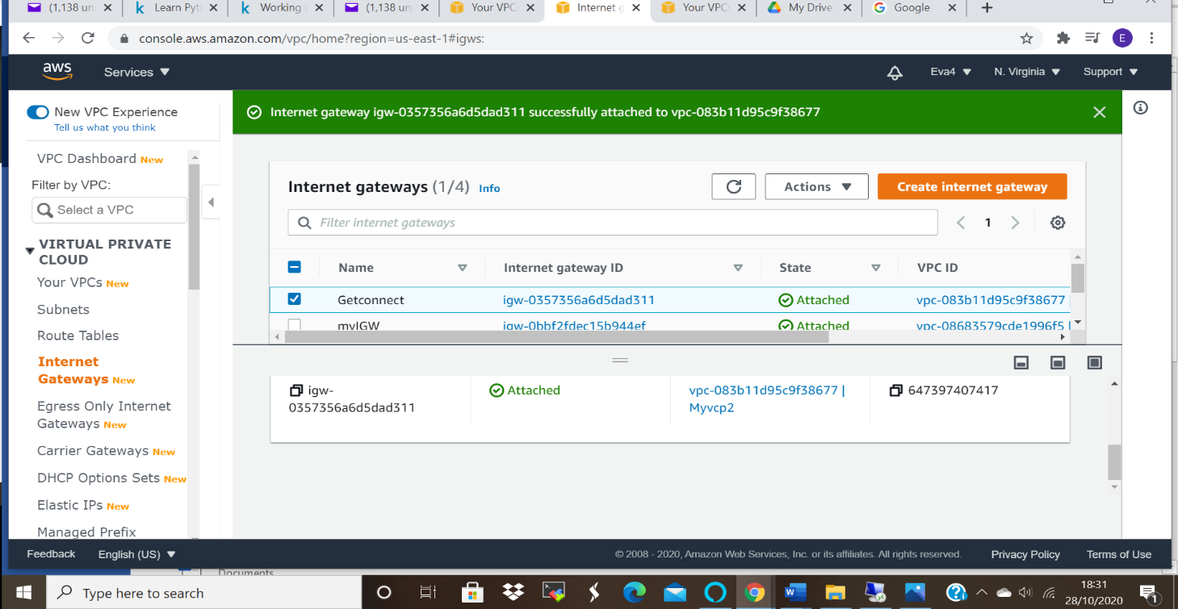

Ss3: edit route list
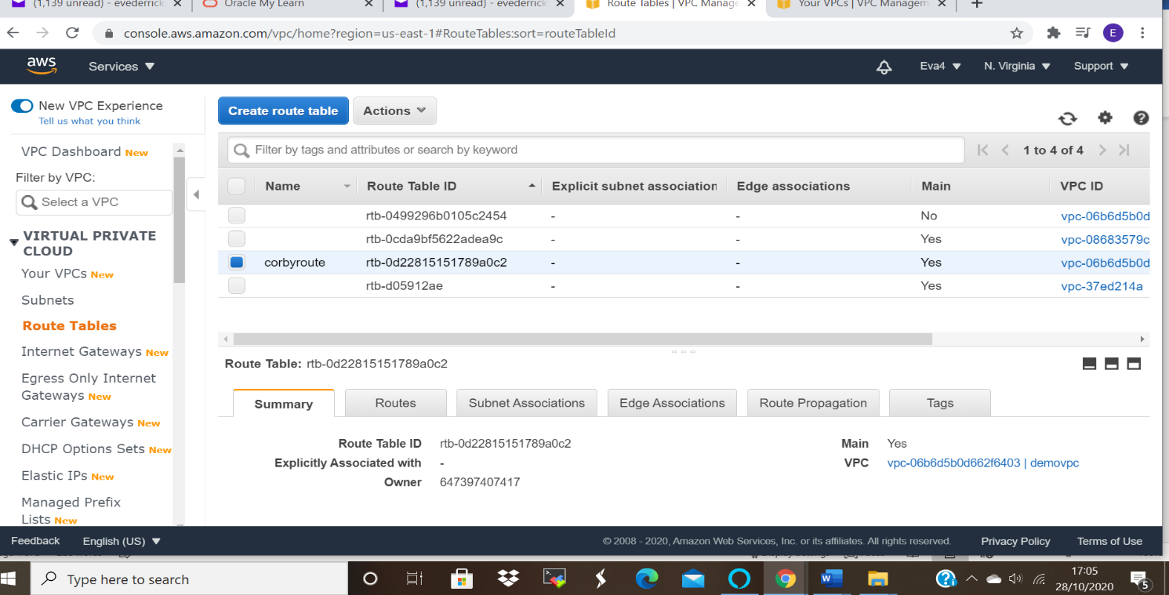

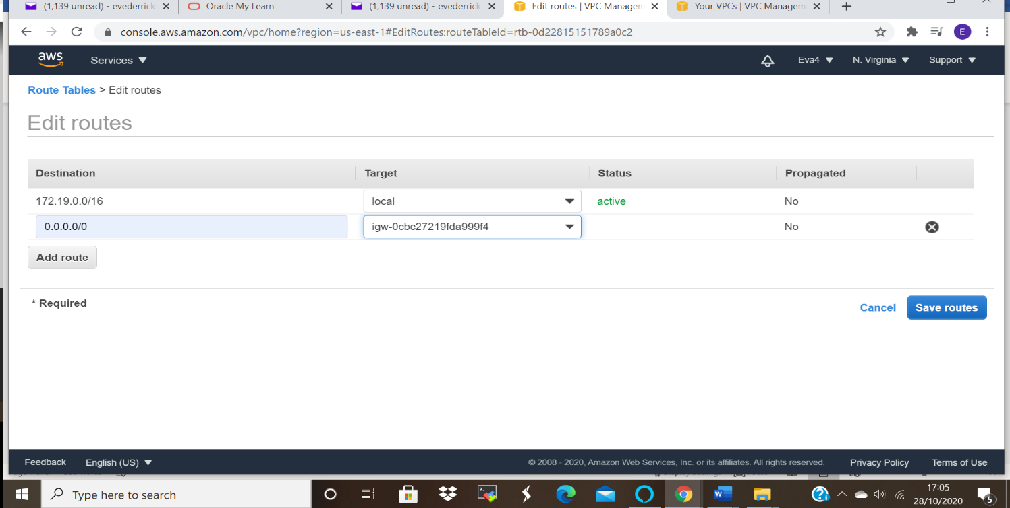

SS for 2 Route Table:

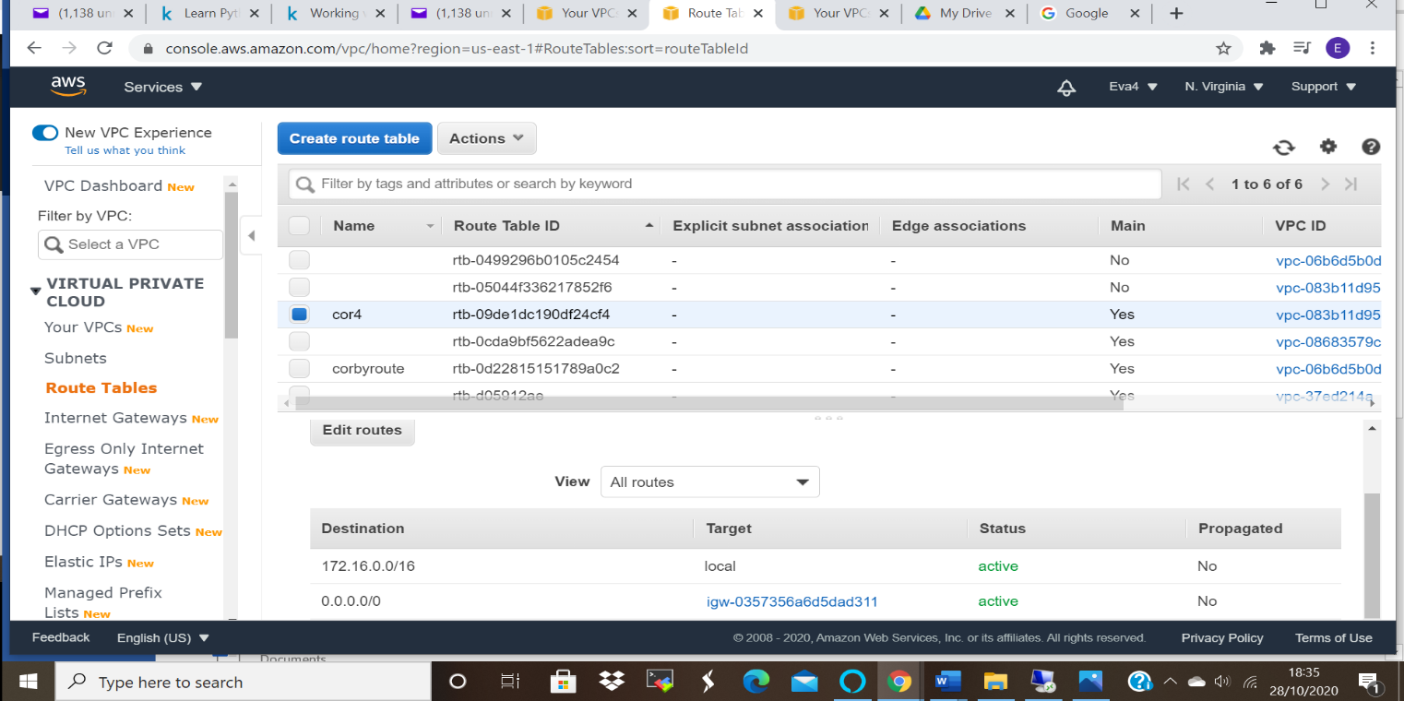

Ss4: subnet list:
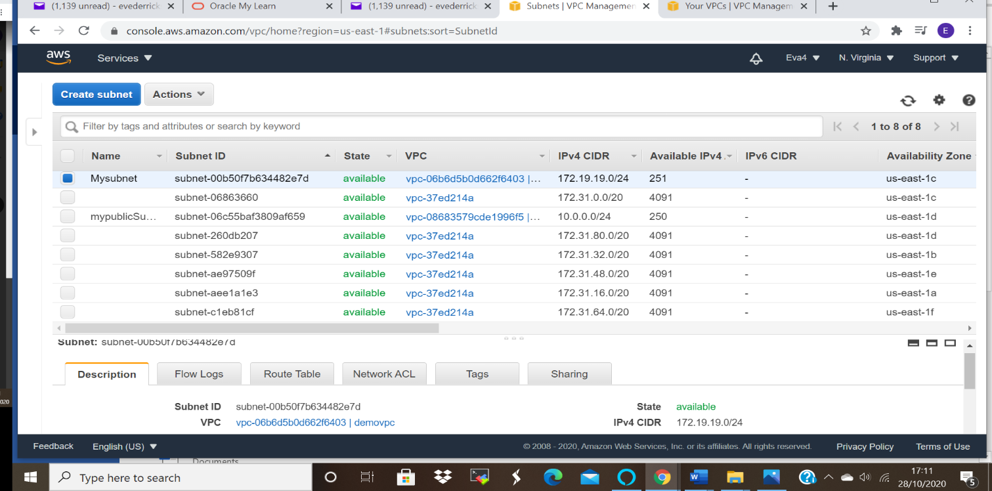

Ss For second subnet:
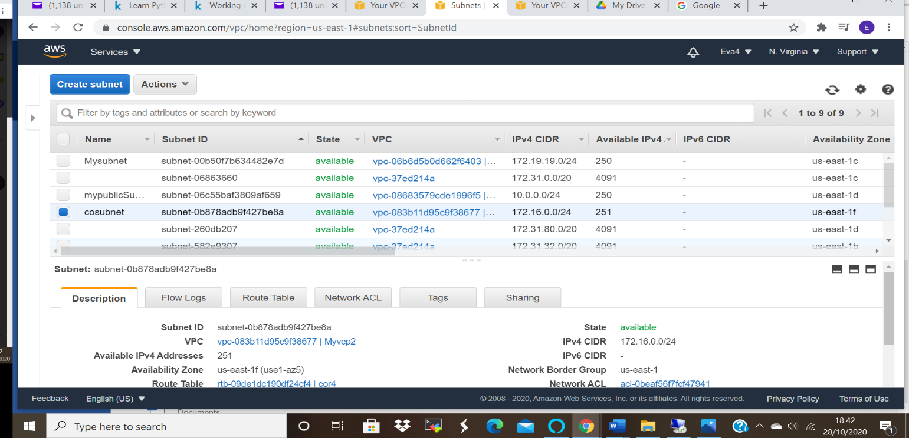

Ss5: instance details
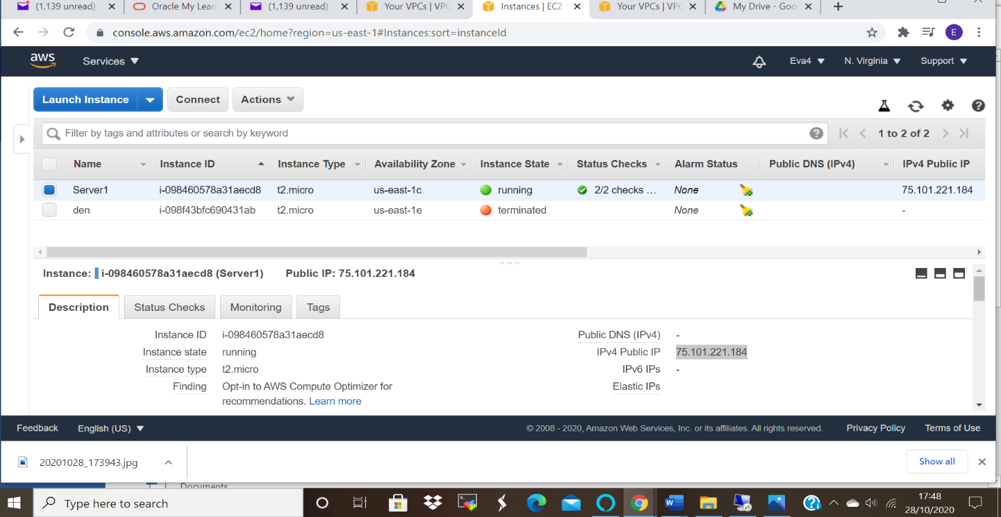

Ss for second Instance:

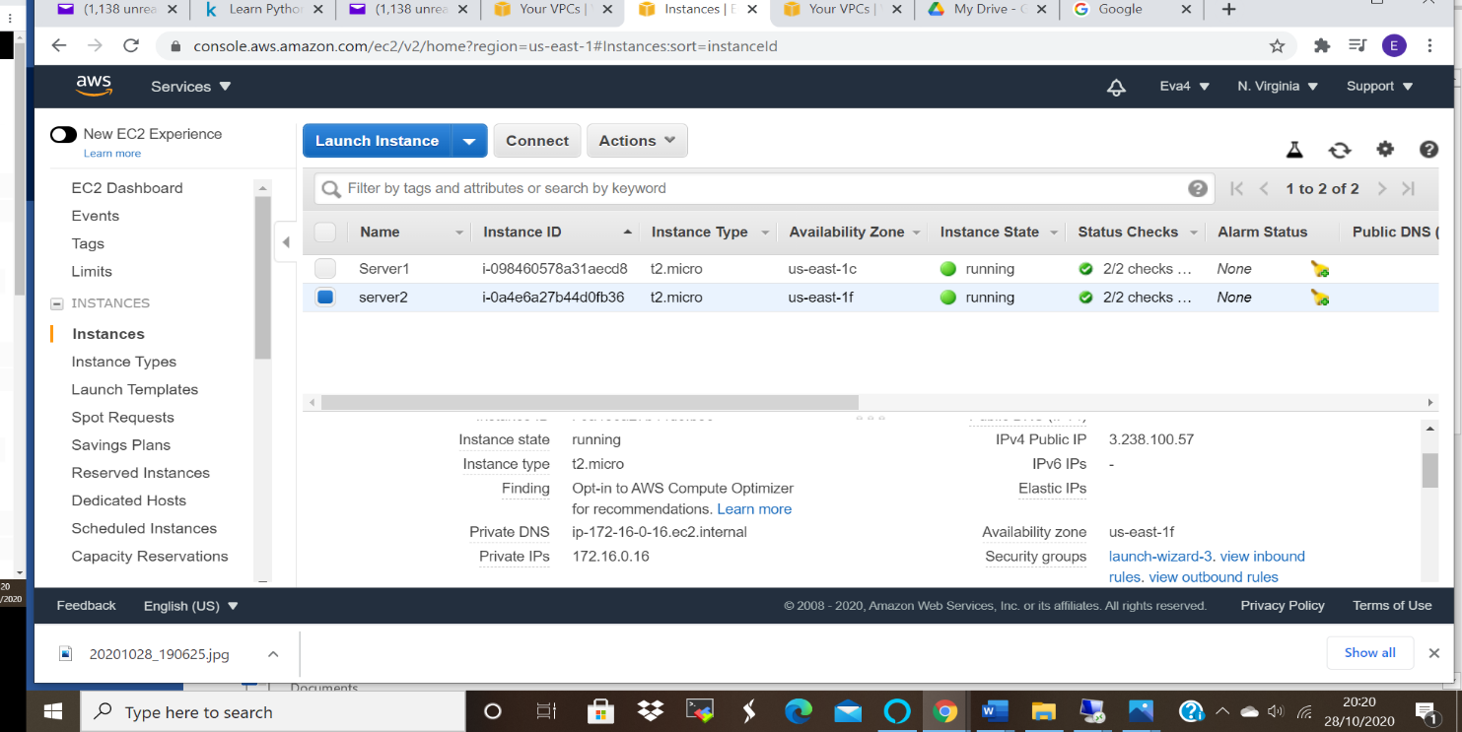

Ss6: success public, request timed out private IP

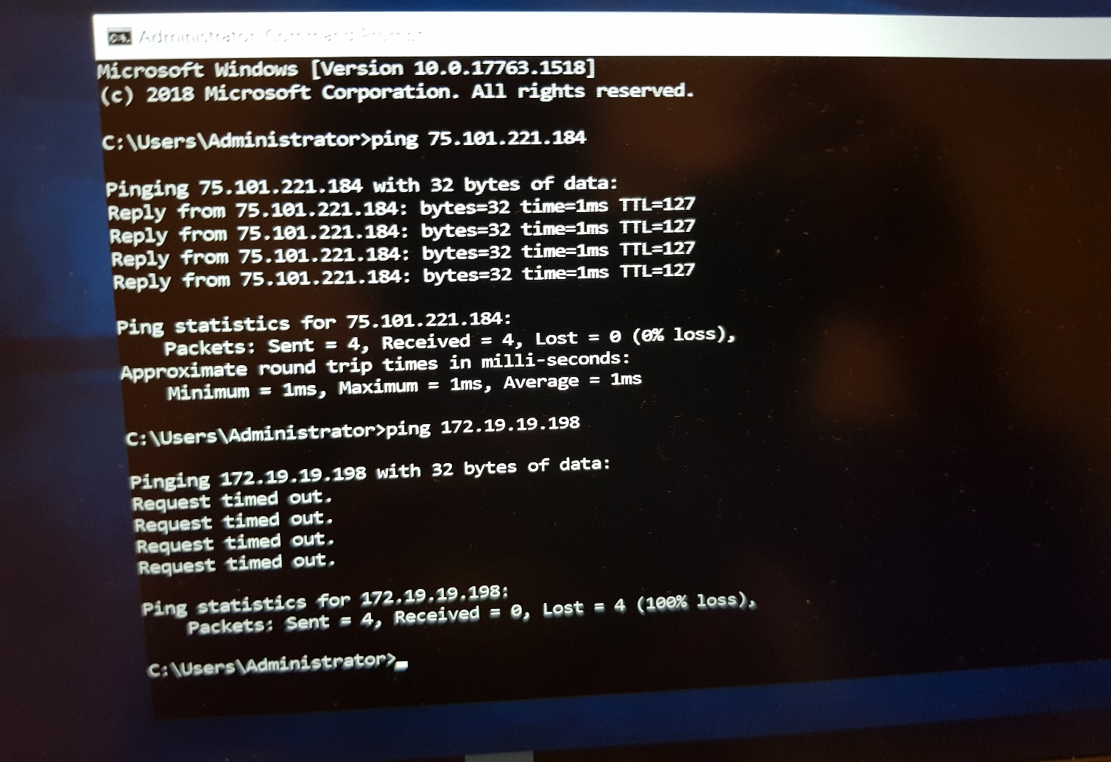

Ss7: peering with requestor and acceptor
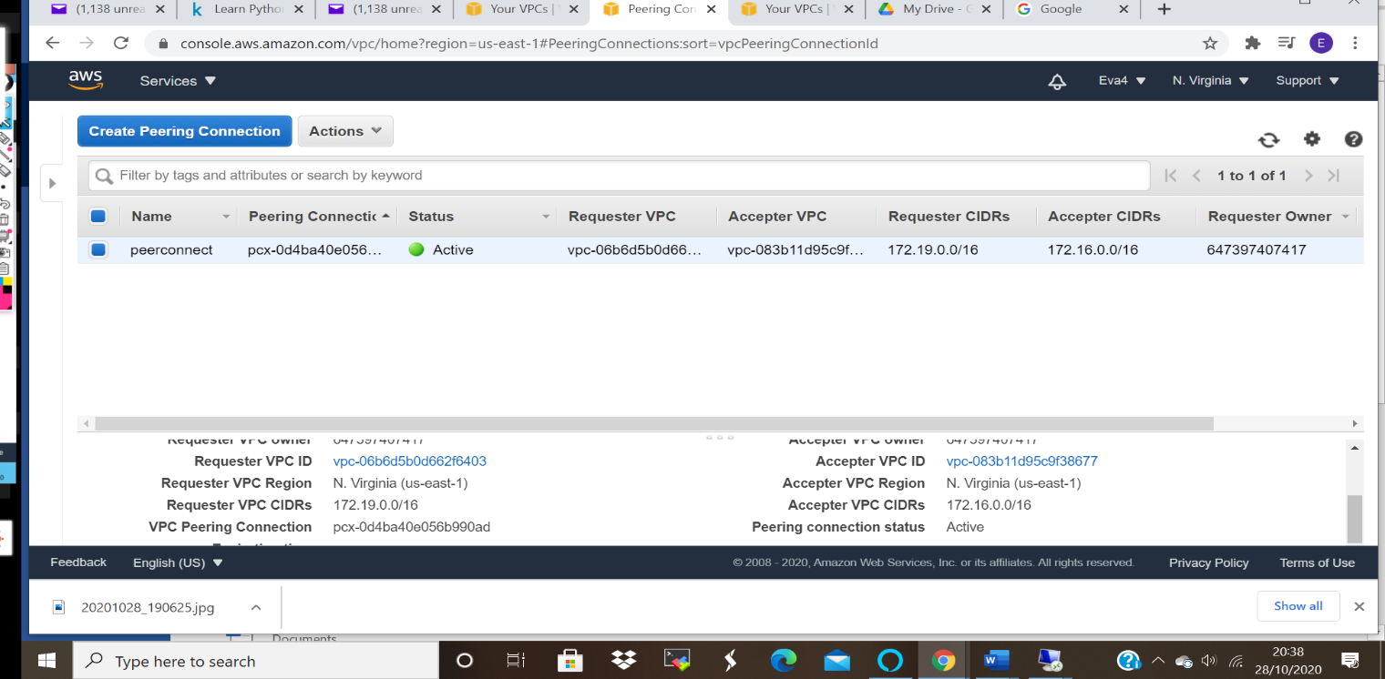

Ss8: success for private
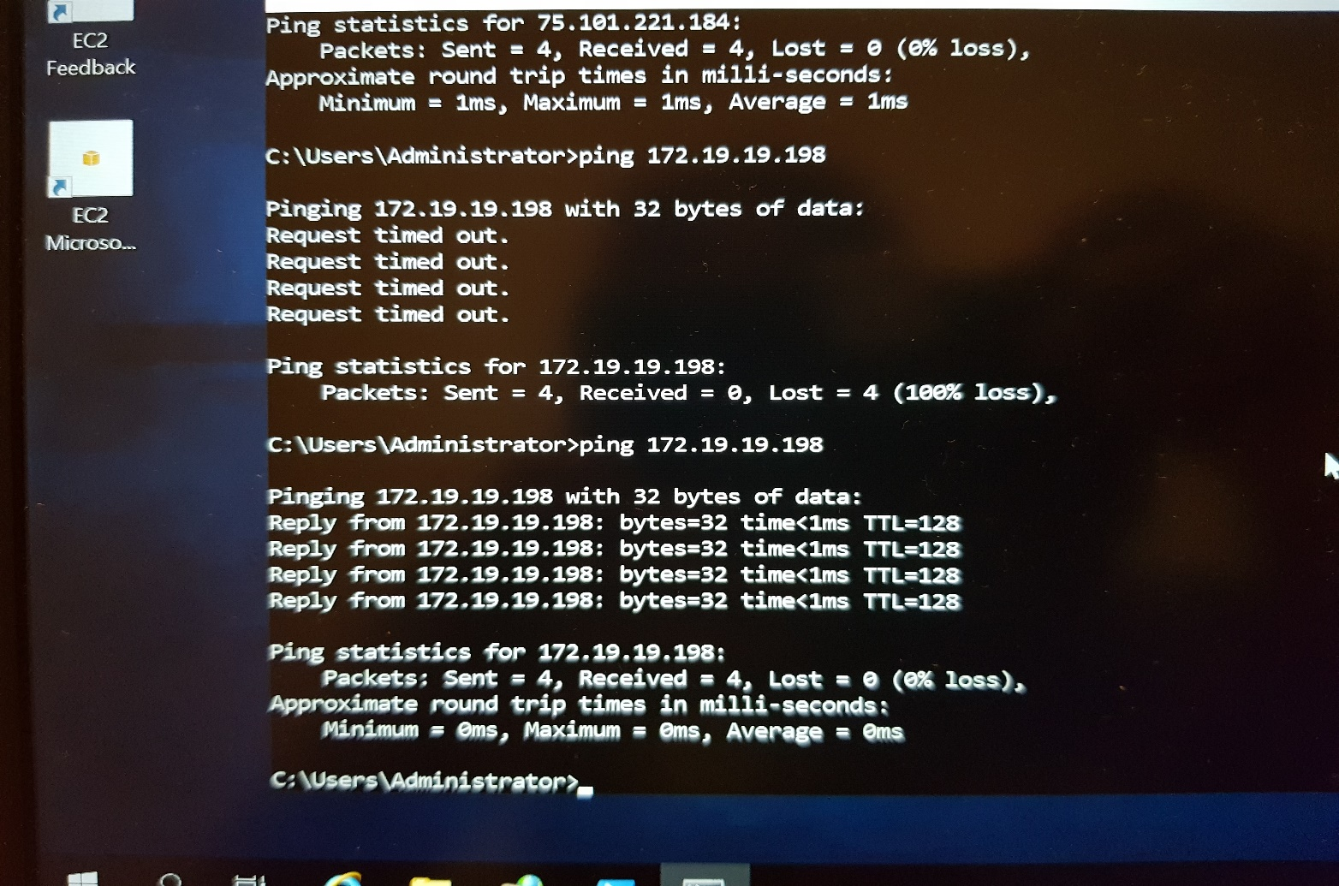

PROJECT 2:
IAM
Task 1: Creating users without permissions-IAM password policy check.
Ss1: User summary with all tab information
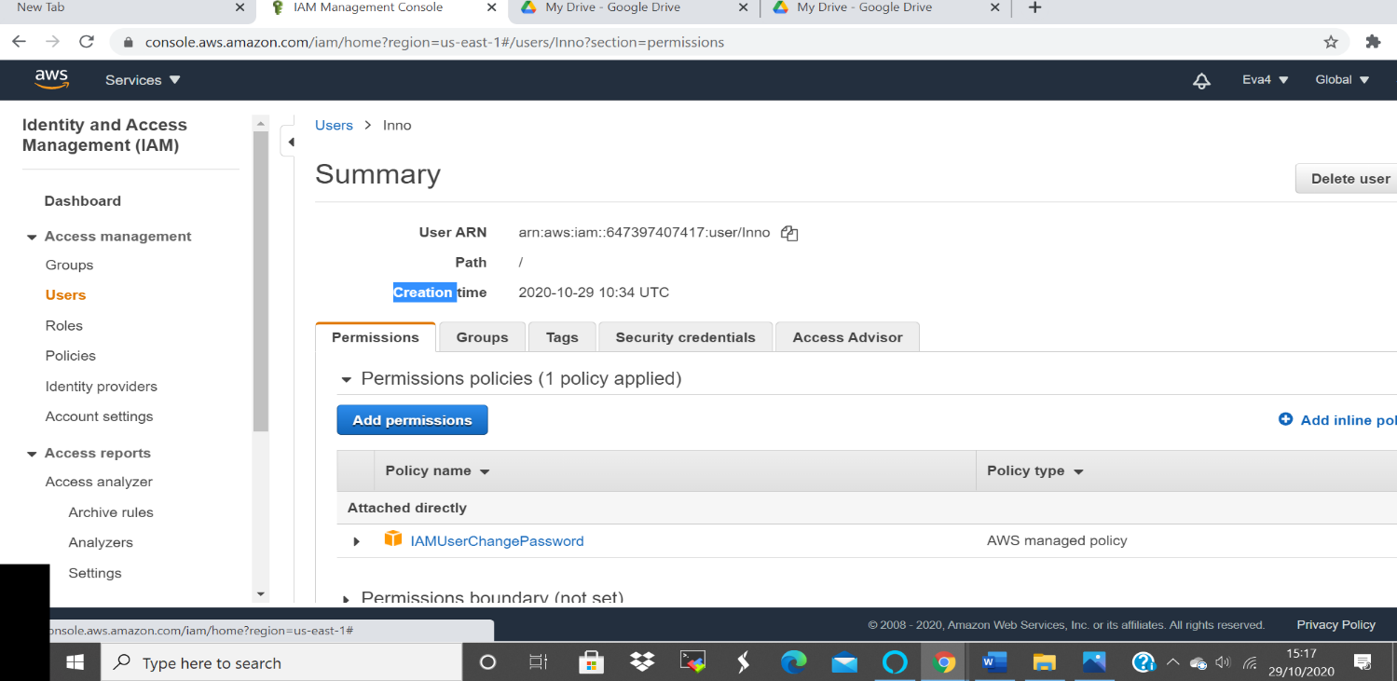

SS: User is not able to access IAM Dashboard since He has no granular permission to do so.
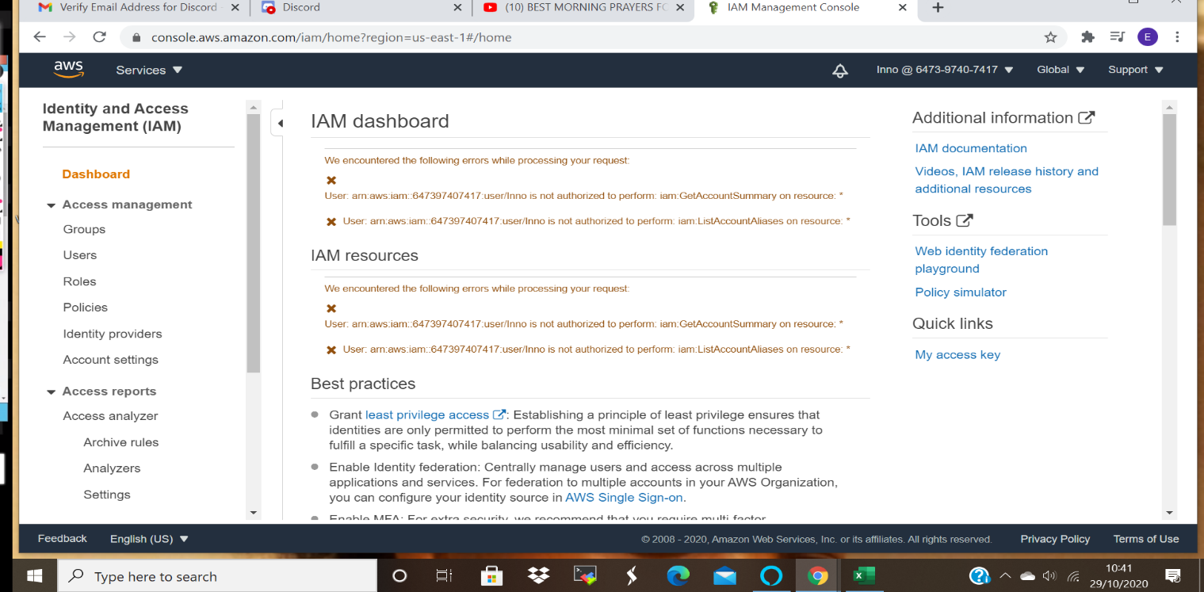

Task 2: Creating users without the IAM password policy.

Ss2: User summary with all tab information
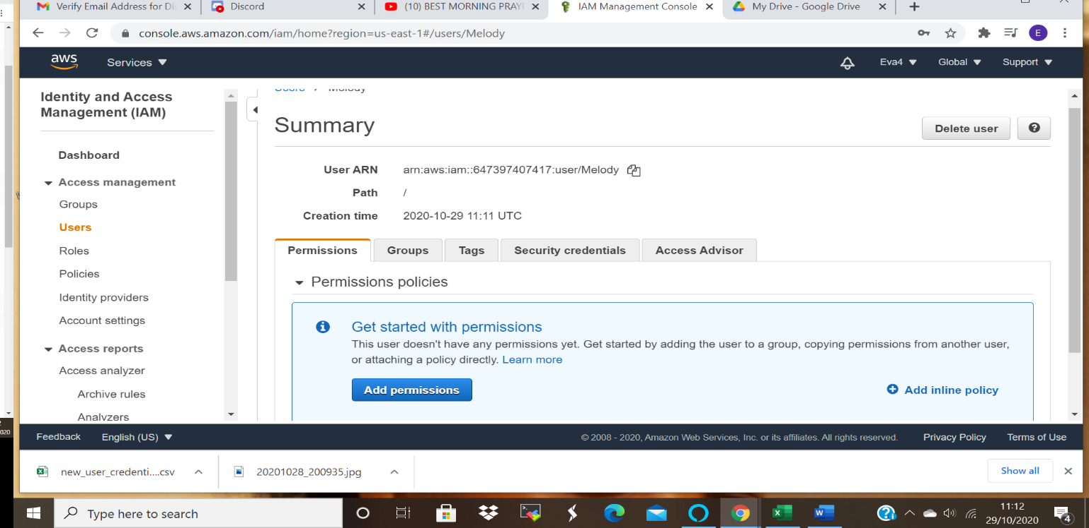

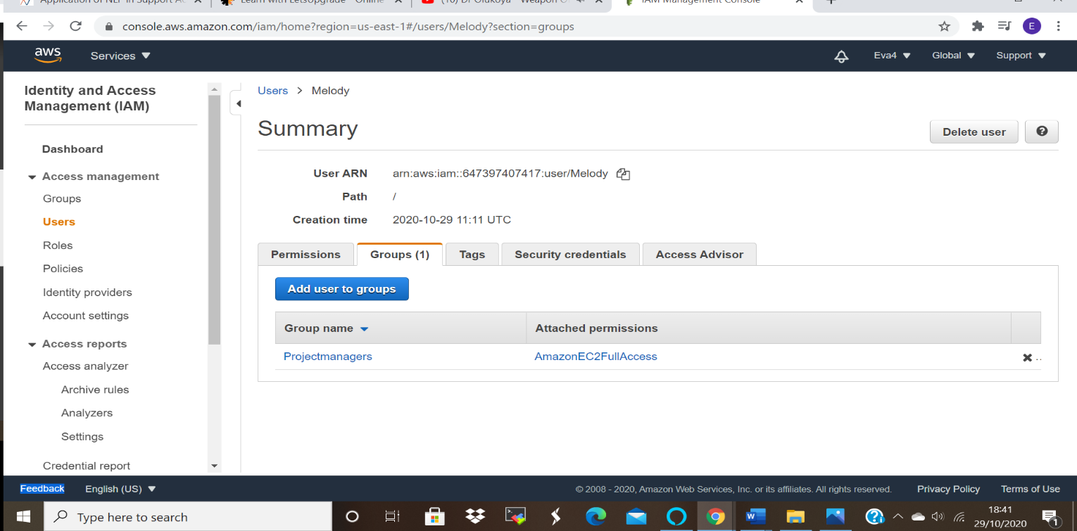
Task 3: Create a user with S3 full access
Ss3: User summary
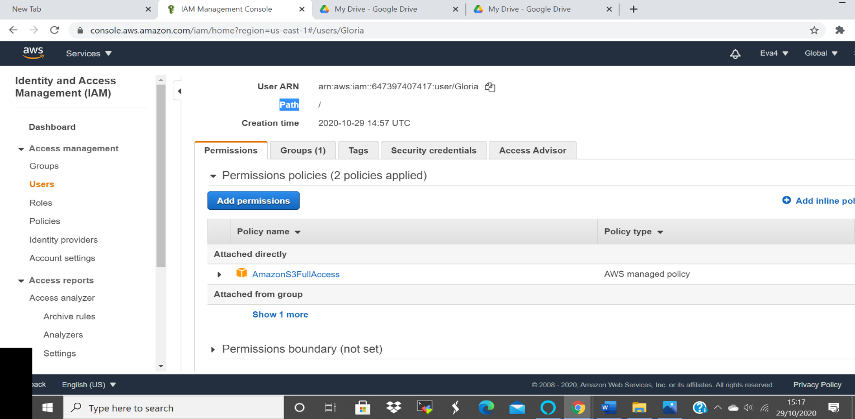

Task4: Create a group with ec2 full access
Ss4: Group summary

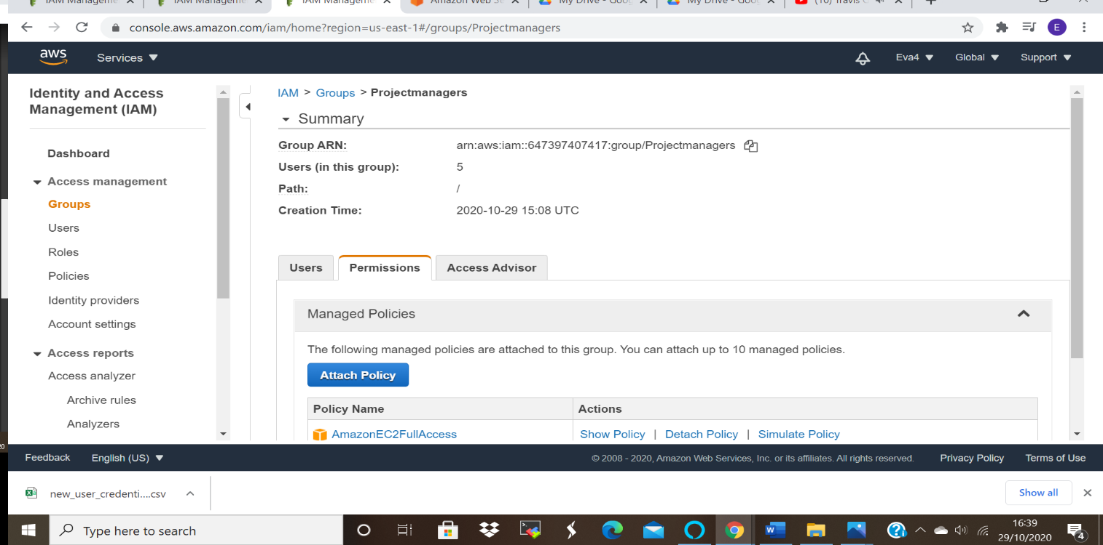
Task 5: Add user to a group and check if user policy and the group policy is reflecting on the user
Ss5: User summary with permissions
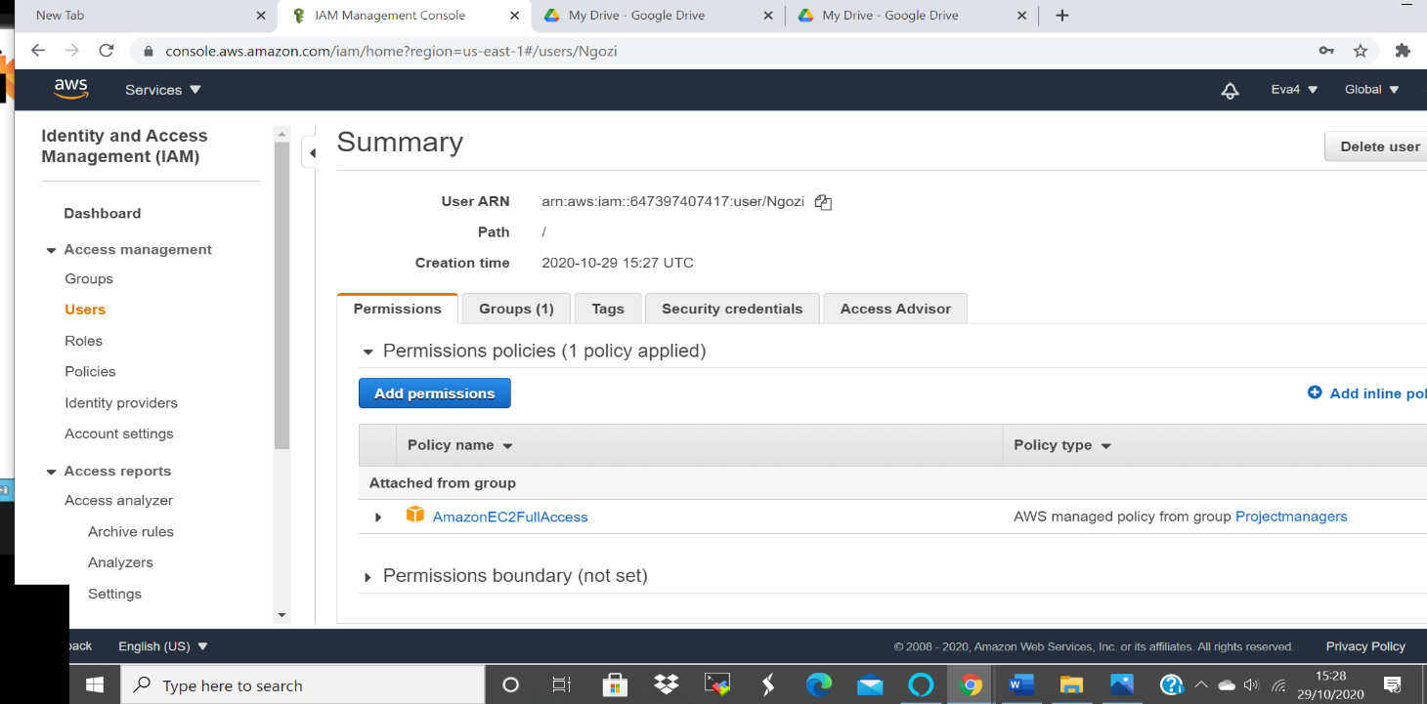

Ss6: Login as this user show that this policy is in effect

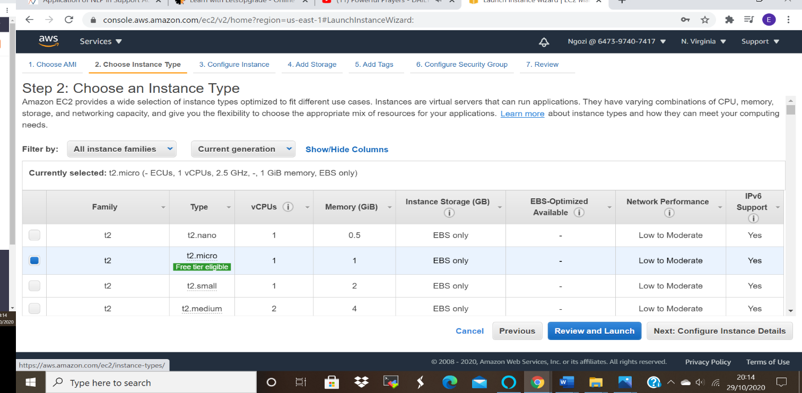

The user cannot access the other services as she only have permission to access EC2 as above Picture.
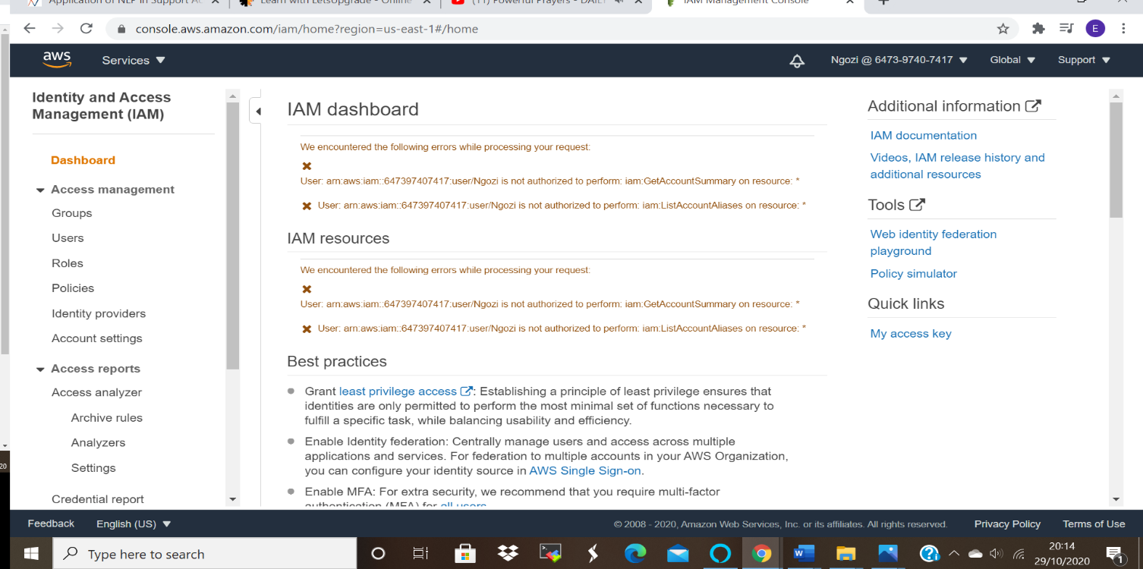
Task 6: Copy policies from the existing user
Ss7: Attach user summary of the user from which you create a new user

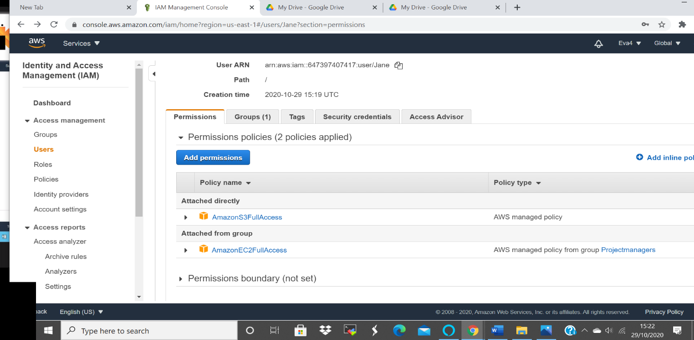

Ss8: Login as this user show that this policy is in effect
User policies copied from User (Gloria and from the group):
Access to EC2:
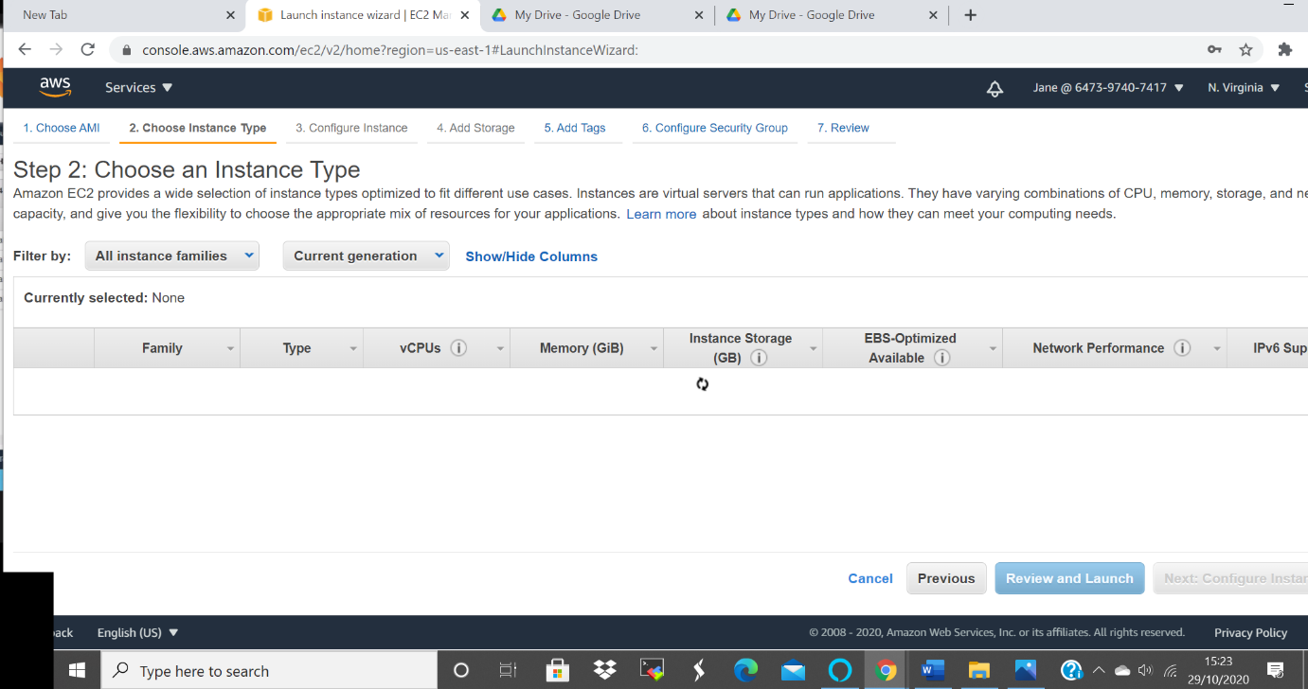

Its able to Access the S3 buckets
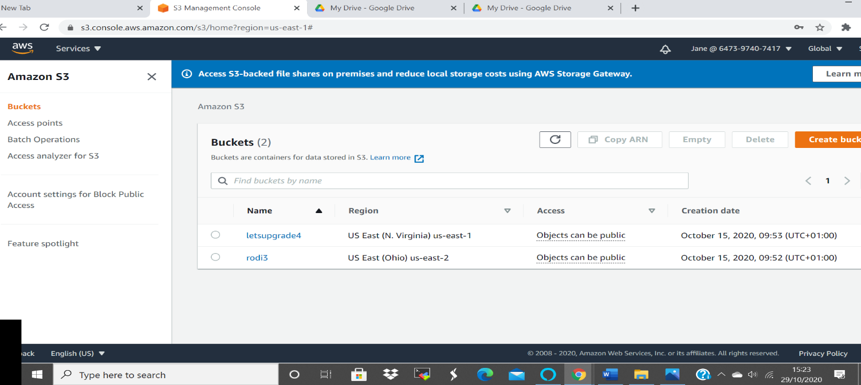

Task 7: Add user to a group in the process of creating a user
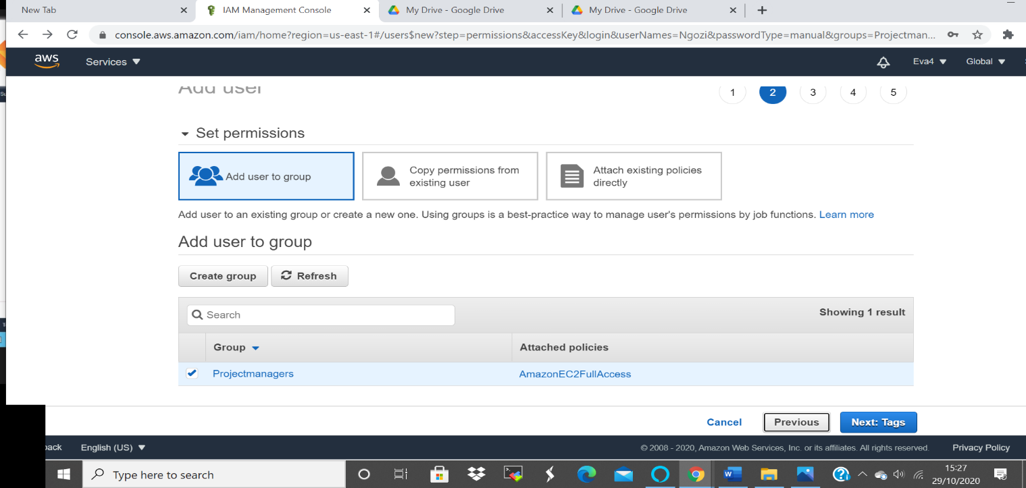

Task8: Setting a password policy
Ss9: Password policy screen
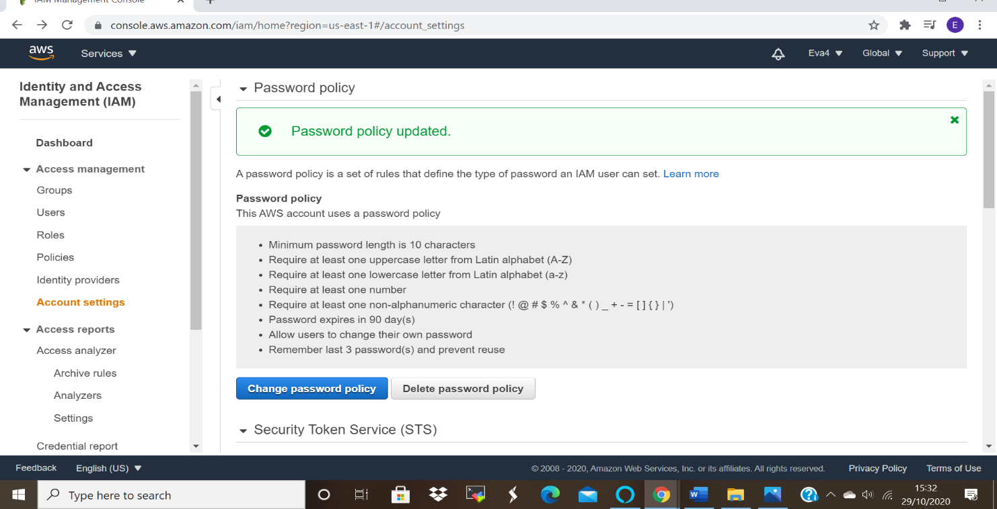

Ss10: Login as the user and show password incompatibility error
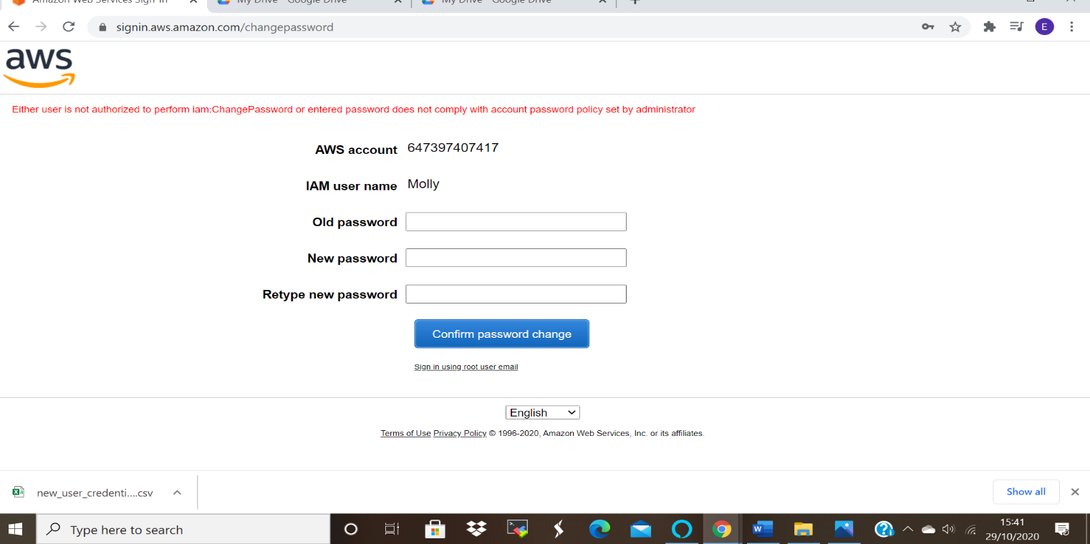

Task 9: Enabling MFA and using an MFA device
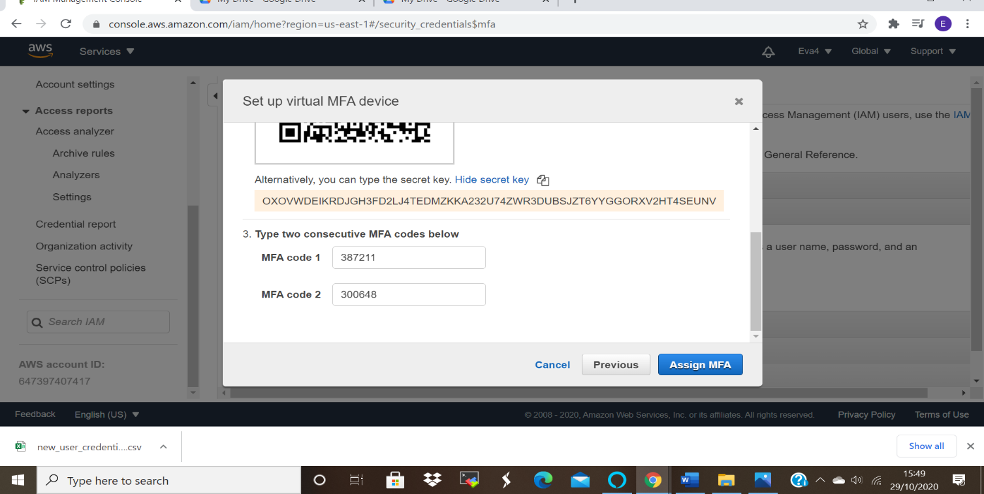
Ss11: Enable MFA

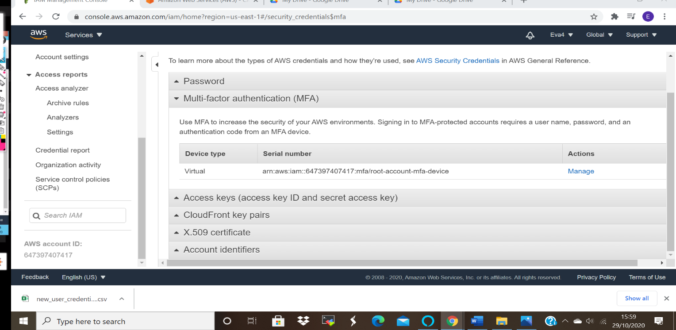

Ss12: Login screen for MFA


